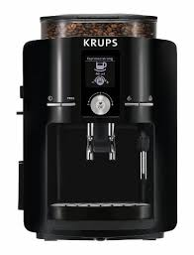

# GOTER CONTOINER

COFFER FITER

WHOTER CONTAINER

CARD

PITCHER

HOT PLDE

BOTTON OF\ON